**User Manual**

**Faculty Purchase Orders Page**

**Team 14**

Richard Rogers, Hector Roldan, Aaron Sandow, Gunnar Skotnicki

|  |
| --- |
| Macintosh HD:Users:gunnarskotnicki:Downloads:screenshots:1.jpg |

Welcome to the UCF EECS Faculty Orders Page. This page will function as the main portal for all the Faculty Ordering Page. Once you’ve arrived to this page you will have two options, either go place an order, or sign into your account. Note that only accountants, purchasers, and an administrator will have the ability to log in. Each level of user account will only have access to certain functions within the site as specified in the specification. If the user does not have an account they will only be able to place orders. The next page explains more about the user manual.

As a note moving forward some of the pictures may differ slightly since this was made during development, however the functionality is still the same.

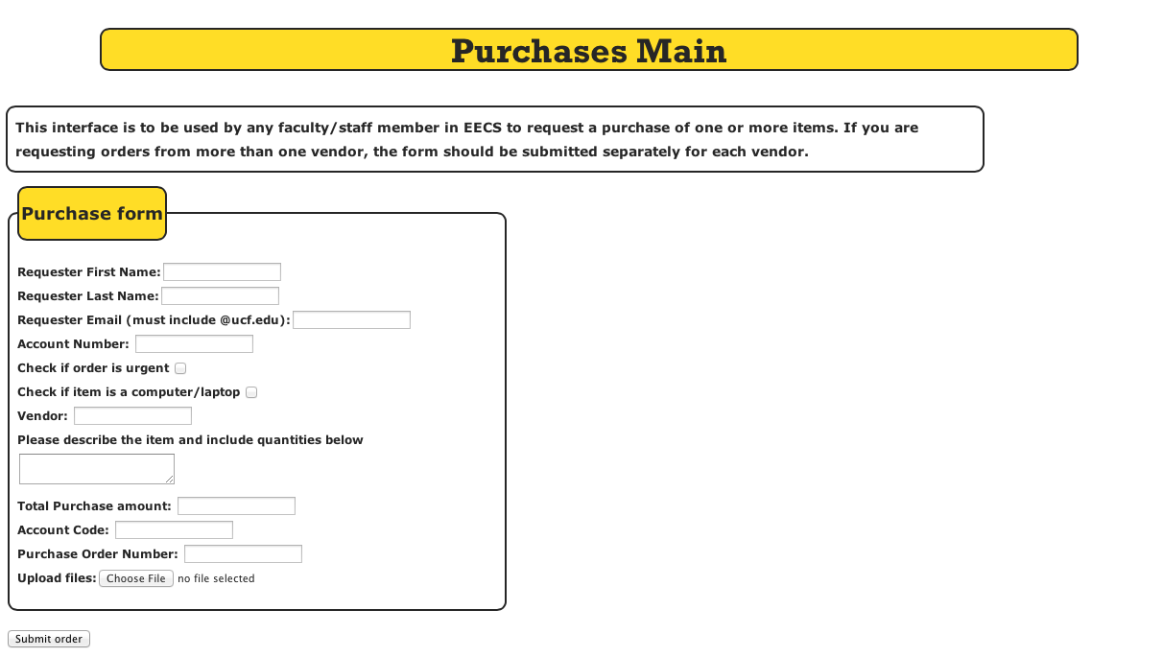

This is the order page, here you will be able to place an order and specify a few things about that order. First off, the user will input their name and email. There are also fields for the account number and two status options. The first asking if this order is urgent, a marked box indicates that the order is urgent, and the second is asking if this order is a laptop/computer so that these orders can be accessed easier. The user can also mention the vendor, describe details about the order, specify the amount, input the account code, and the purchase order number. Once the user hits submit the order will be sent into the database and stored that way it can be accessed later. The next page discusses what you will see when you log in.

|  |
| --- |
| Macintosh HD:Users:gunnarskotnicki:Desktop:Screen Shot 2014-04-15 at 11.22.20 AM.png |

Once a user logs in this page will greet them, this user manual will go through this section of the manual as an administrator. This matters because depending on the account level they will only be able to see certain queries and they will also only be able to see specific categories from those queries. At the top there is a navigation bar this allows for the user to have quick access to any of the main links. The Add Order page is the same as the last page discussed, logout will log you out of your account, a link to account settings with the only option currently to change your password, a link to add a new user, and a link to bring you to this select query page.

|  |
| --- |
| Macintosh HD:Users:gunnarskotnicki:Desktop:Screen Shot 2014-04-14 at 1.14.34 PM.png |

Right below the “Click here for account settings” link the user is able to select what they look up from various options within the dropdown menu. The next page will talk more in-depth about that.

This is the breakdown of the admin’s view for selecting different queries.

|  |
| --- |
| Macintosh HD:Users:gunnarskotnicki:Desktop:Screen Shot 2014-04-14 at 1.14.46 PM.png |

All orders and view users return all results for each of those tables. There are certain dropdowns for “Accountant” these are viewable by the admin, however are more important to the accountant as it limits the fields of the orders that they can view, and overall is tailored to their needs. Moving past those first few options the names are mostly self-explanatory. Each query that would require additional information brings you to a page where you can enter in the values you’d like. For example if you do “Find Order By Email” it will bring you to a new page that you then can enter the email address, if there is a match you’ll receive the results back.

|  |
| --- |
| Macintosh HD:Users:gunnarskotnicki:Desktop:Screen Shot 2014-04-14 at 1.15.40 PM.png |

This is the result from the View Users query, this allows you to see various information about each user and allowing you to edit and delete users as well. Notice at the top the admin has an option to add a new user and the same navigation bar as earlier. The next graphic shows the edit users page, the UserID, password and Username cannot be changed but any other factor to their account can be.

|  |
| --- |
| Macintosh HD:Users:gunnarskotnicki:Desktop:Screen Shot 2014-04-15 at 11.24.55 AM.png |

|  |
| --- |
| Macintosh HD:Users:gunnarskotnicki:Downloads:screenshots:9.jpg |

Above is a view of the Add User page, this page will allow the admin to add a new user into the system specifying whether they’re an accountant or purchaser. This page is very simplistic to make it clear to see what to add in order to add another user.

|  |
| --- |
| Macintosh HD:Users:gunnarskotnicki:Desktop:Screen Shot 2014-04-14 at 1.15.15 PM.png |
| Macintosh HD:Users:gunnarskotnicki:Desktop:Screen Shot 2014-04-14 at 1.15.24 PM.png |

Above is the return of the All Orders query and this is broken down for the admin, each blue label at the top of the tables allows sorting of that particular column. At the end of the table the admin can choose to edit an order, and remove an order.

|  |
| --- |
| Macintosh HD:Users:gunnarskotnicki:Desktop:Screen Shot 2014-04-15 at 11.20.59 AM.png |
| Macintosh HD:Users:gunnarskotnicki:Desktop:Screen Shot 2014-04-15 at 11.21.09 AM.png |

These two above pictures show what the admin will see when they’re trying to edit an order, this page will generate with the information that is already tied to that order. Once the desired changed are made this form will submit and update the database with the new information.

While this user manual gives a walk through in the admin’s shoes, most of the site was designed to be very clear to users and allow for ease of use, and even at that most users won’t even be within the logged-in portion of the site.

**The Environment – The Technical Jargon**

Currently the website is being ran on a Linux Ubuntu 12.04v VPS hosted by DigitalOcean for the purposes of testing and presentation. This can easily be transferred to a new Linux server. The required technologies are PHP 5.3.10-1, Apache 2.2.22, Java version 1.6.0_30, Google's GSON library, PHP mail script and mySQL server version 5.5.35-0. For this project there were no virtual hosts set up for apache and this was just developed using the default index for apache (/var/www/). Certainly this project would be able to be set up with virtual hosts however that is server dependent. Once all the above components have been installed placing the corresponding files into the directory should allow the website to be up and running aside from the database. For the database all that will need to be done is to create the database that you want to use and then the commands we provide for creating the tables and stored procedures/function. Once the database has been populated with the stored procedures and function, calling the AddUser procedure to add the admin account will be required (after that point all users could be added through the website with that admin account). The only catch to the AddUsers for adding the admin is that the eKey/final parameter needs to be the same as the admin password, since certain items are encrypted based on the admin's password. It is crucial that the admin does not forget their password since the database is encrypted based on that value, the admin is of course able to change their password though.

**Steps-**

1. Install required technologies and put the files in the proper directory
   1. Change all the file directories to the appropriate URL, as it won’t be 107.170.96.213 once implemented on a new server.

**2.** Fill mySQL database with tables and stored procedures and function.

**3.** Populate the User's table with at least an Admin account.

These are the only steps required to get the site fully running, since after there is an admin account they can fully navigate the site, add users, and manage various parts of the site and database.